Your application for the role of Retail Customer Service Assistant4
Yahoo
/
Sent

Shantanu Panigrahi <shantanupanigrahi@yahoo.com>
To:
BPRetailJobs
Cc:
Enquiries Kent Police, Force Control Kent Police, Enquiries Medway County Court,
Central London DJSKEL, Civil Appeals - Registry, omar.sagher@governmentlegal.gov.uk,
ccmcce-filing@justice.gov.uk, arun@orbitmediasolution.com, Human Resources (Sainsburys)
Hide

Wed, 7 Sept at 07:47

To
BP

Dear Sirs

1. I never sent you an email threatening to burn down the petrol station that you reported to Kent Police which led to PC Evans reporting me for Psychiatric assessment to Britton House and Mr Micahel Quarm interrogated me for in May this year. You should have done your homework and investigated the source of the criminal anonymous email that impersonated me on this particular occasion (and there were plenty of other such malicious emails such as to Katrina Sale, and staff of the BLM Law Firm, my wife and relatives in India and to Sainsburys, Tesco and my GP Surgeries at Wigmore Medical Centre and Long Catlis Road.

2. It is clear that you are holding that against me in my search for fresh new employment that I need urgently to make ends meet. You should take into account that Deputy District Judge Harvey never intended to direct any other person or institution to discard emails received from me: I have checked this as linked here: Deputy District Judge Harvey's Directions and Order (knowledgeassessmentanddissemination.com) https://www.knowledgeassessmentanddissemination.com/post/deputy-district-judge-harvey-s-directions-and-order

Deputy District Judge Harvey's Directions and Order
Deputy District Judge Harvey's Directions and Order2 Yahoo/Sent Shantanu Panigrahi <shantanupanigrahi@yahoo.com>...

3. Accordingly, Kent Police, Medway County Court, the Court of Central London, Adminstrative Court and the Court of Appeal should expedite the Claims J00ME572 and E35YM660 (under the new Prime Minister Miss Liz Truss) and CO/1680/2002.

4. I have an appointment with Sainsburys at Hempstead Valley Shopping Centre tomorrow Thursday 8 September 2022 and I do not wish for anything to go wrong in this opportunity which could be my last attempt at securing employment that is convenient to me.

Yours sincerely

Dr Shantanu Panigrahi
3 Hoath Lane
Wigmore
Gillingham
Kent ME8 0SL
Tel: 07967789619

Hide original message
----- Forwarded message -----
From: bp Recruitment Team <donotreply@bpretailjobs.co.uk>
To: "shantanupanigrahi@yahoo.com" <shantanupanigrahi@yahoo.com>
Sent: Wednesday, 7 September 2022 at 06:47:24 BST
Subject: Your application for the role of Retail Customer Service Assistant

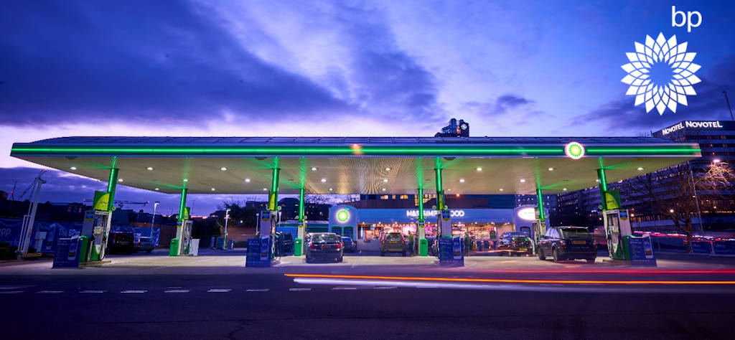

Hi Shantanu,
Thank you for your application for Retail Customer Service Assistant, reference 32928.

We have had a large volume of strong applications for this role and it was extremely difficult to create a shortlist. Unfortunately, on this occasion you have not been selected for interview.
I would like to thank you for your interest in bp and we wish you all the success in finding your next role.
Kind Regards,
bp retail recruitment team - UK
bp plc, Witan Gate House, 500-600 Witan Gate, Milton Keynes, MK9 1ES
Disclaimer
The information in this e-mail is confidential and may be legally privileged. It is intended solely for the addressee(s) only. Access to this email by anyone else is unauthorised. If you are not the intended recipient, any disclosure, copying, distribution or an action taken or omitted to be taken in reliance on it, is prohibited and may be unlawful. Within the bounds of the law, electronic transmissions through internal and external networks may b monitored to ensure compliance with internal policies and legitimate business purposes.
Please do not reply to this email address as it is not monitored.
__________________________________________________________________________________
ccmcce-filing <ccmcce-filing@justice.gov.uk>
To:
Shantanu Panigrahi

Wed, 7 Sept at 07:47

Thank you for your email which has been received by the County Court Money Claims Centre (CCMCC). This email is automatically generated; please don’t reply to this message.

Please retain this email as receipt that your email has been received.

Please refrain from submitting unnecessary duplicate documents by only using one method of either email, post or fax.

Please follow the attached guidance for filing documents electronically.

Processing Times

Details of processing and reply times for work at the County Court Money Claims Centre (Salford) and the County Court Business Centre (Northampton) can now be found here.

The information will be updated every Monday.

Feedback

HMCTS promises to listen, to explain and to guide. Only you can tell us if we’re living up to this promise. So please take a few minutes to tell us about your experience using this link.

Praise – If you’ve any praise for the CCMCC or its staff we would love to hear from you, you can email us at CCMCCPraise@justice.gov.uk

Complaint - If you’ve cause to complain you can do so online.

Alternatively, please email ccmccandccbc-complaints@justice.gov.uk

You don’t need to resubmit feedback already submitted online.

Please allow 10 working days for your concerns to be investigated and a response provided. You can find further guidance on our complaints procedure on the Justice Website.

Court Forms

If you require any Court Forms please follow this link.

Court Finder

Should you need the contact details of another Court please follow this link.

CCMCC Telephone Enquiries - 0300 123 1372

Opening times

08:30 – 17:00 Monday – Thursday

08:30 – 16:00 Friday

This e-mail and any attachments is intended only for the attention of the addressee(s). Its unauthorised use, disclosure, storage or copying is not permitted. If you are not the intended recipient, please destroy all copies and inform the sender by return e-mail. Internet e-mail is not a secure medium. Any reply to this message could be intercepted and read by someone else. Please bear that in mind when deciding whether to send material in response to this message by e-mail. This e-mail (whether you are the sender or the recipient) may be monitored, recorded and retained by the Ministry of Justice. Monitoring / blocking software may be used, and e-mail content may be read at any time. You have a responsibility to ensure laws are not broken when composing or forwarding e-mails and their contents.
Download all attachments as a zip file
Advice Agencies
.pdf
269.3kB
Sources of support
.pdf
729.6kB
Top tips for our customers
.pdf
303.8kB
Request to Stop Issue - Customer Guidance
.pdf
400.3kB
Email Guidance v6.
.pdf
510.3kB
__________________________________________________________________________________
Central London DJSKEL <centrallondondjskel@justice.gov.uk>
To:
Shantanu Panigrahi

Wed, 7 Sept at 07:47

Thank You for your email message which is now in the judicial email inbox. This inbox is only viewed by judiciary and court staffs do not have access to this account. This auto response confirms that the message has arrived and will be dealt with in due course.

Thank You
This e-mail and any attachments is intended only for the attention of the addressee(s). Its unauthorised use, disclosure, storage or copying is not permitted. If you are not the intended recipient, please destroy all copies and inform the sender by return e-mail. Internet e-mail is not a secure medium. Any reply to this message could be intercepted and read by someone else. Please bear that in mind when deciding whether to send material in response to this message by e-mail. This e-mail (whether you are the sender or the recipient) may be monitored, recorded and retained by the Ministry of Justice. Monitoring / blocking software may be used, and e-mail content may be read at any time. You have a responsibility to ensure laws are not broken when composing or forwarding e-mails and their contents.

{EID1-82-n4d6FajlC0CIE3xGlIV0wA} 1-7

__________________________________________________________________________________
Your Ask HR request has been created
Yahoo
/
Inbox

Ask HR <er.support@sainsburys.co.uk>
To:
Shantanu Panigrahi

Wed, 7 Sept at 07:47

Hi Shantanu,

Your question "Fw: Your application for the role of Retail Customer Service Assistant" (82916) has been created, we'll get back to you as quickly as possible.

You can add more details at any time by replying to this email or logging into Ask HR and selecting ‘My Requests’

The Ask HR Team
https://askhr.sainsburys.co.uk

P.S: If you wish to opt out of email notifications, you can update your Profile in Ask HR at any time.

Show original message

Ask HR
Sainsbury's
This email is a service from Ask HR. Delivered by Zendesk
[MQOWVW-WD7ZK]
__________________________________________________________________________________
Automatic reply: Your application for the role of Retail Customer Service Assistant
Yahoo
/
Inbox

HRAdv ERAdmin <hradv.eradmin@sainsburys.co.uk>
To:
Shantanu Panigrahi

Wed, 7 Sept at 07:47

﻿

Thanks for getting in touch. We’ve got your email and a member of the team will review it shortly.

We will aim to get back to you in the next 72 hours (Monday to Friday). In the meantime if you have any questions relating your query please feel free to speak to a Line Manager within your location.

For guidance or further information on policy relating to Appeals or Fair Treatments (grievances) please call 08000 153030 to speak to a member of the AskHR team.

This email and any files transmitted with it are confidential and intended solely for the use of the individual or entity to whom they are addressed. If you have received this email in error please notify the system manager (postmaster@sainsburys.co.uk) and delete it from your system.

Sainsbury's Supermarkets Ltd (3261722 England)
Registered Offices: 33 Holborn, London, EC1N 2HT

Sainsbury’s Argos is a trading name of both:
1) Argos Limited, Registered office: 489-499 Avebury Boulevard, Milton Keynes, United Kingdom, MK9 2NW, registered number: 01081551 (England and Wales); and
2) Sainsbury’s Supermarkets Limited, Registered office: 33 Holborn, London, EC1N 2HT, registered number: 03261722 (England and Wales).

All companies listed above are subsidiaries of J Sainsbury plc (185647).

Show original message
__________________________________________________________________________________

